Task 2: Customer Segmentation Using Unsupervised Learning

1. Problem Statement & Objective:
Customer segmentation is the process of dividing customers into groups based on shared characteristics. In this task, we aim to segment mall customers based on their annual income and spending score using unsupervised machine learning. The goal is to help businesses understand their customer base and design targeted marketing strategies for each segment.

2. Dataset Description:
Dataset: Mall Customers Dataset Source: Kaggle
Column | Description
CustomerID | Unique ID for each customer
Gender | Male or Female
Age | Age of the customer
Annual Income (k$) | Annual income in thousands of dollars
Spending Score (1-100) | Score assigned by the mall based on spending behavior
- Rows: 200 customers
- Features: 5 columns
- No missing values

3. Exploratory Data Analysis (EDA):
EDA is performed before applying any model to understand the structure and distribution of data.
Steps performed:
- Checked shape, data types, and null values
- Plotted gender distribution using countplot
- Used pairplot to observe relationships between all numerical features
- Analyzed distribution of Age, Income, and Spending Score
Key Observations:
- Female customers slightly outnumber male customers
- Most customers fall in the 25–45 age range
- Spending score and annual income show no strong linear correlation, making clustering meaningful
- Customers with high income do not always have high spending scores

4. Data Preprocessing:
Preprocessing ensures the data is clean and ready for the model.
Steps performed:
- Stripped column names of extra spaces
- Encoded the Gender column using Label Encoding (Male = 1, Female = 0)
- Selected Annual Income and Spending Score as the two main clustering features
- No missing values were found so no imputation was needed

5. K-Means Clustering:

What is K-Means?
K-Means is an unsupervised machine learning algorithm that groups data points into K clusters. Each data point is assigned to the nearest cluster center (centroid), and centroids are updated iteratively until convergence.

How it works:
- Initialize K centroids randomly
- Assign each data point to the nearest centroid
- Recalculate centroids as the mean of assigned points
- Repeat steps 2–3 until centroids stop changing

Elbow Method:
To find the optimal number of clusters (K), we use the Elbow Method. We plot WCSS (Within-Cluster Sum of Squares) against different values of K. The point where the curve bends like an elbow is the best K value.
In this task, K = 5 was identified as the optimal number of clusters.

Why K-Means?
- Simple and efficient for large datasets
- Works well when clusters are roughly spherical

6. PCA - Dimensionality Reduction:

What is PCA?
Principal Component Analysis (PCA) is a technique that reduces high-dimensional data into fewer dimensions while preserving maximum variance. It transforms correlated features into uncorrelated principal components.

Why use PCA here?
Even though we only used 2 features for clustering, PCA is applied to:
- Confirm cluster separability visually
- Demonstrate how the technique scales to higher-dimensional datasets
- Provide a 2D visualization of cluster distribution

7. Cluster Analysis & Marketing Strategies:
After applying K-Means with 5 clusters, the following segments were identified:
Cluster | Income | Spending Score | Profile | Marketing Strategy
1 | High | High | Ideal Customers | Loyalty rewards, premium offers
2 | Low | Low | Budget Conscious | Discounts, value deals
3 | High | Low | Potential Targets | Personalized offers, engagement campaigns
4 | Low | High | Impulsive Spenders | Flash sales, limited-time deals
5 | Medium | Medium | Regular Customers | Membership programs, seasonal promotions

8. Model Evaluation:
K-Means is an unsupervised algorithm so there are no labels to compare against. Instead, we evaluate using:
Metric | Description
WCSS (Inertia) | Sum of squared distances from each point to its centroid — lower is better
Elbow Method | Visual method to pick optimal K
Cluster Visualization | Scatter plot with colored clusters and marked centroids

Code:
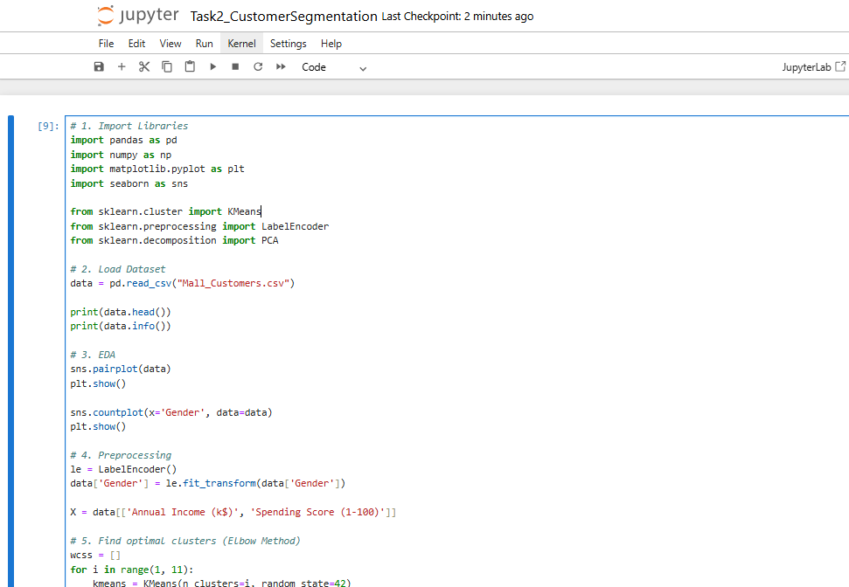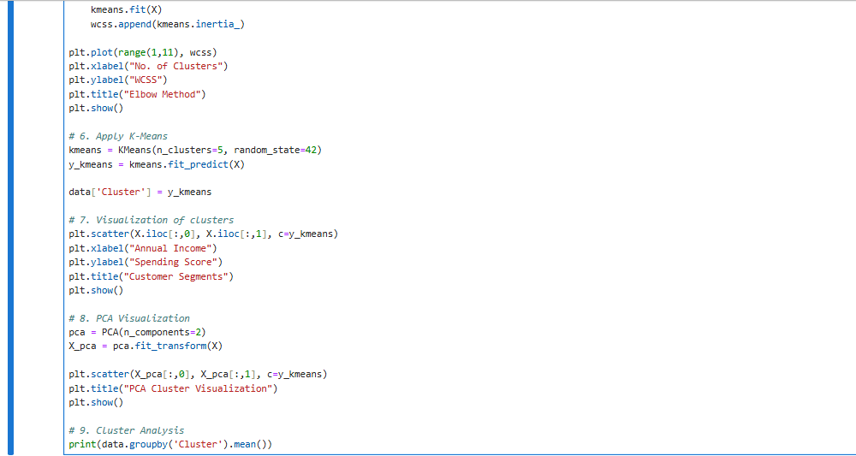
Output: 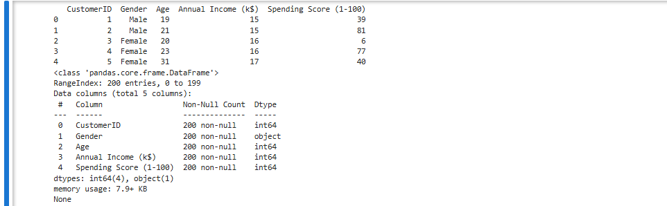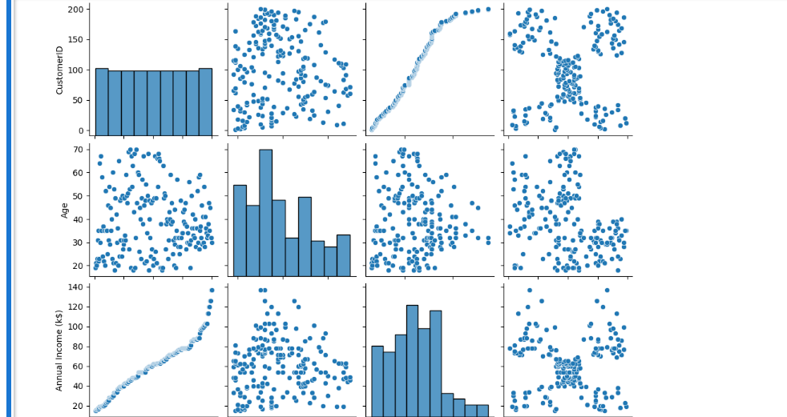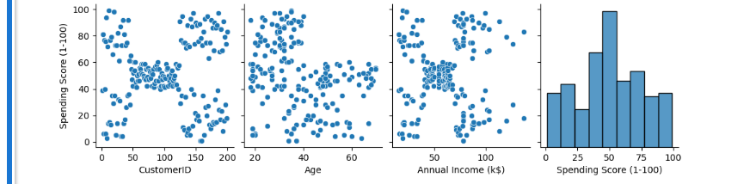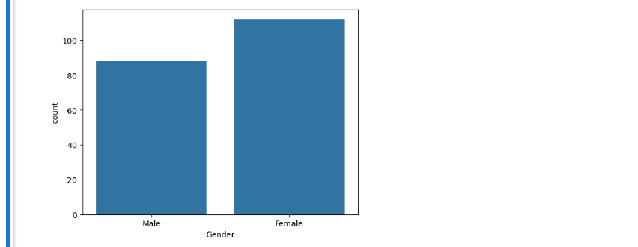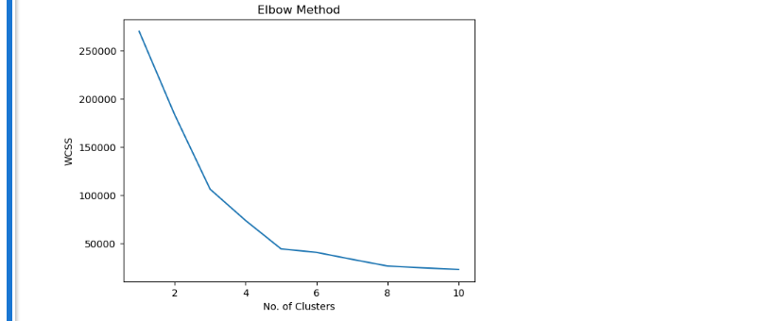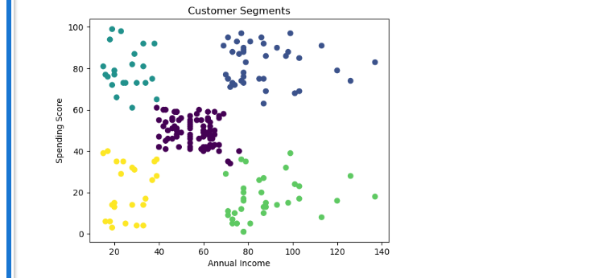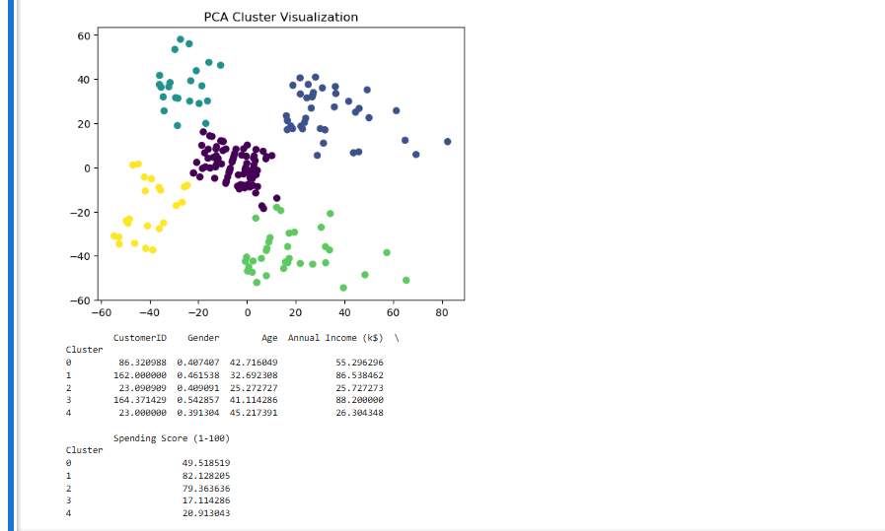

9. Conclusion & Insights:
- K-Means successfully segmented 200 customers into 5 meaningful groups
- The Elbow Method confirmed K=5 as the optimal cluster count
- PCA visualization showed well-separated clusters confirming good segmentation quality
- Each segment has distinct income-spending behavior enabling targeted marketing
- Businesses can use these insights to increase revenue by focusing efforts on high-value segments and converting potential customers

10. Skills Gained:
- Unsupervised Machine Learning (K-Means Clustering)
- Dimensionality Reduction (PCA)
- Exploratory Data Analysis (EDA)
- Data Preprocessing and Label Encoding
- Customer Profiling and Business Strategy Development
- Data Visualization with Matplotlib and Seaborn

